Teach Ag — NY Agricultural Education (nysffa.org)
SUNY Cobleskill Agricultural Education Pathway
(links to)
SUNY Cobleskill prepares students through hands-on, technical education and establishes a broad foundation of agriculture knowledge that can be applied to teaching agricultural education. Associate and Bachelor’s level degree offerings at SUNY Cobleskill such as Agricultural Business, Plant Science, Animal Science or Agricultural Engineering paired with an Agricultural Education minor allow students to specialize in a program area while also preparing for graduate school and pursuing a teaching degree.
See Programs of Study (cobleskill.edu) to learn more about SUNY Cobleskill’s academic programs.
To review the Agricultural Education minor, see College Catalog (cobleskill.edu).
Request more information: Request More Information (cobleskill.edu)
Set up a college visit and connect with us: Visit Campus Overview (cobleskill.edu)
The State University of New York College of Agriculture and Technology at Cobleskill has been a leader in hands-on learning for more than a century. We look forward to providing you with innovative, experiential learning that prepares you for agriculture education certification.
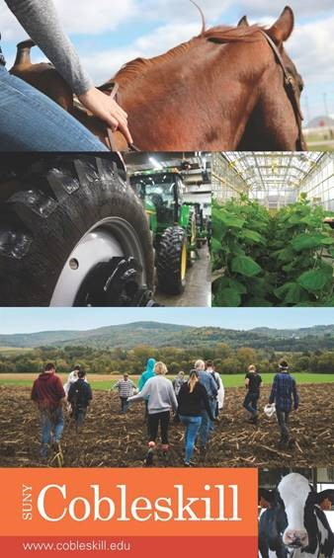
Home | SUNY Cobleskill

