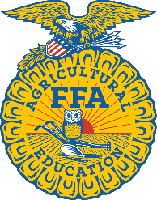
2023-2024 Agricultural Education
Incentive Grant for Growing Programs
Administrator Letter of Support & Acknowledgement

School District School Name
Administrator’s Name Agriculture Teacher’s Name
By signing this acknowledgement, I understand that the agricultural education teacher is submitting an application to be awarded a 2023-2024 Agricultural Education Incentive Grant for Growing Programs.
If the agricultural education program at our school is awarded a 2023-2024 Agricultural Education Incentive Grant for Growing Programs, all funds must be used for the sole purpose of benefitting the agricultural education program, its students, and the teacher to enhance local delivery of a comprehensive, three-component agricultural education program. Grant funds are not a replacement for school district support and funds may not be used to supplant existing funding for consumables.

Administrator’s Signature Agriculture Teacher’s Signature

Date Date

